Examples of 3D graph sketching
Yue Kwok Choy
Visualizing a 3D graph is interesting. The following examples give you some hints in sketching.

1. Sketch the graph $z=x^{2}+y^{2}-4x+6y+13$

$z=x^{2}+y^{2}-4x+6y+13={\left(x-2\right)}^{2}+{\left(y+3\right)}^{2}$

(A) x-y plane view
When z = 0, ${\left(x-2\right)}^{2}+{\left(y+3\right)}^{2}=0$， we get a point $\left(2,-3\right)$.
When z = 1, ${\left(x-2\right)}^{2}+{\left(y+3\right)}^{2}=1$， we get a circle with centre $\left(2,-3\right)$ and radius 1.
When z = 4, ${\left(x-2\right)}^{2}+{\left(y+3\right)}^{2}=2^{2}$， we get a circle with centre $\left(2,-3\right)$ and radius 2.
When z = 9, ${\left(x-2\right)}^{2}+{\left(y+3\right)}^{2}=3^{2}$， we get a circle with centre $\left(2,-3\right)$ and radius 3.

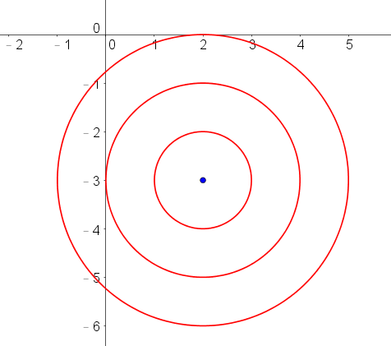

(B) x-z plane view
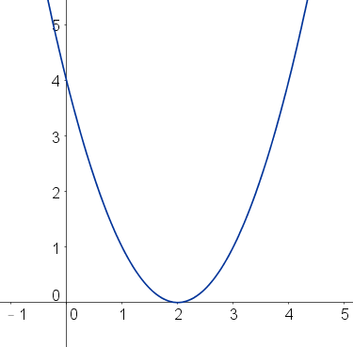 When $y=-3$, we get $z={\left(x-2\right)}^{2}$, which is a parabola.

(C) y-z plane view
When $x=2$, we get $z={\left(y+3\right)}^{2}$, which is a parabola.
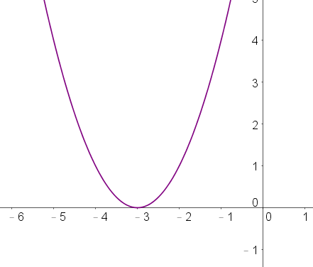
The result is a paraboloid, shown below:

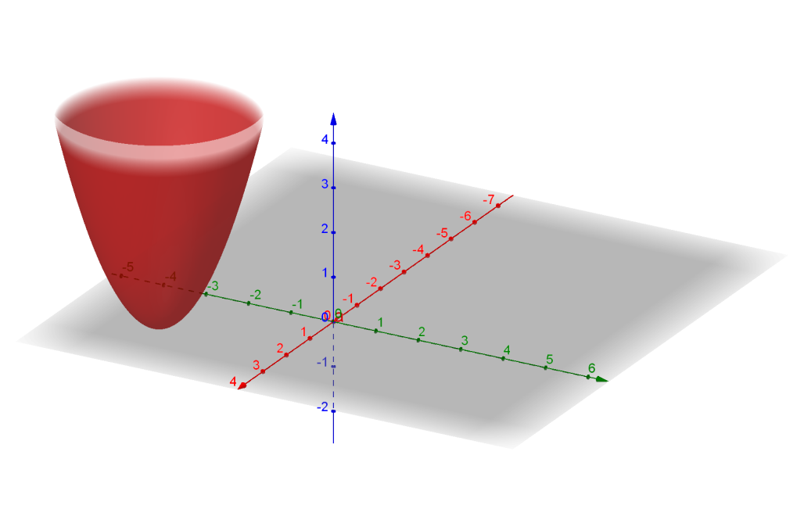

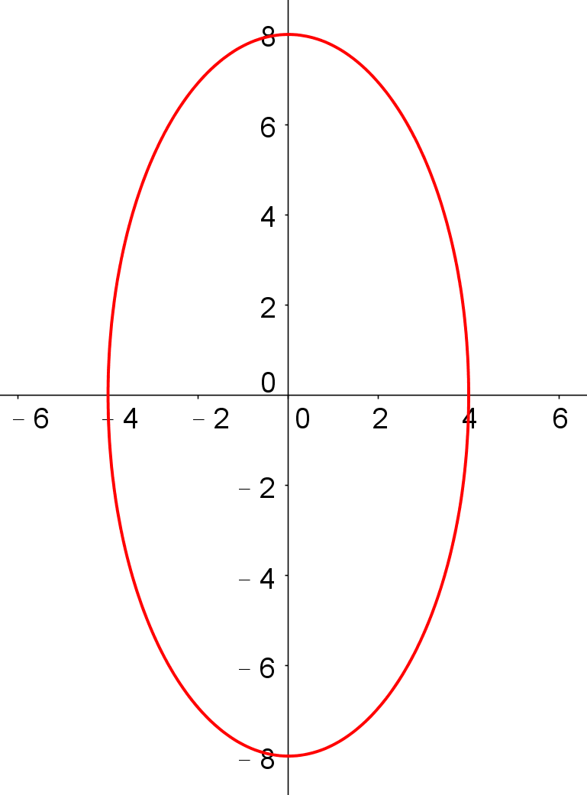2. Sketch the graph $z=\sqrt{64-4x^{2}-y^{2}}$

(A) x-y plane view
When z = 0, $64-4x^{2}-y^{2}=0,$
$\frac{x^{2}}{4^{2}}+\frac{y^{2}}{8^{2}}=1$, which is an ellipse.

(B) x-z plane view
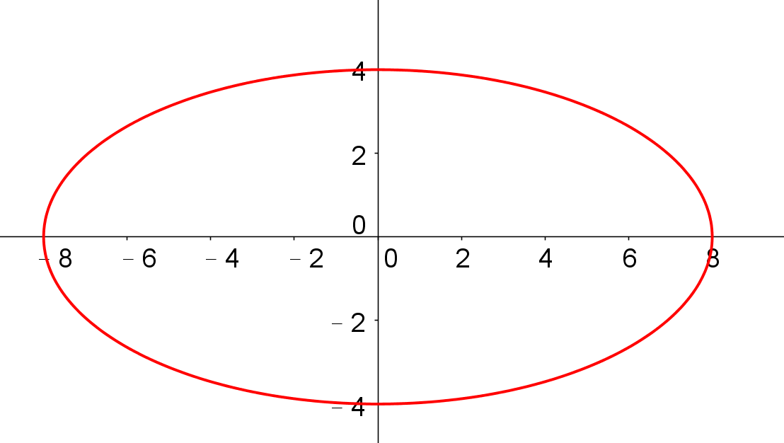 When $y=0$, $z^{2}=64-4x^{2}$,
$\frac{x^{2}}{8^{2}}+\frac{z^{2}}{4^{2}}=1$, which is an ellipse.

(C) y-z plane view
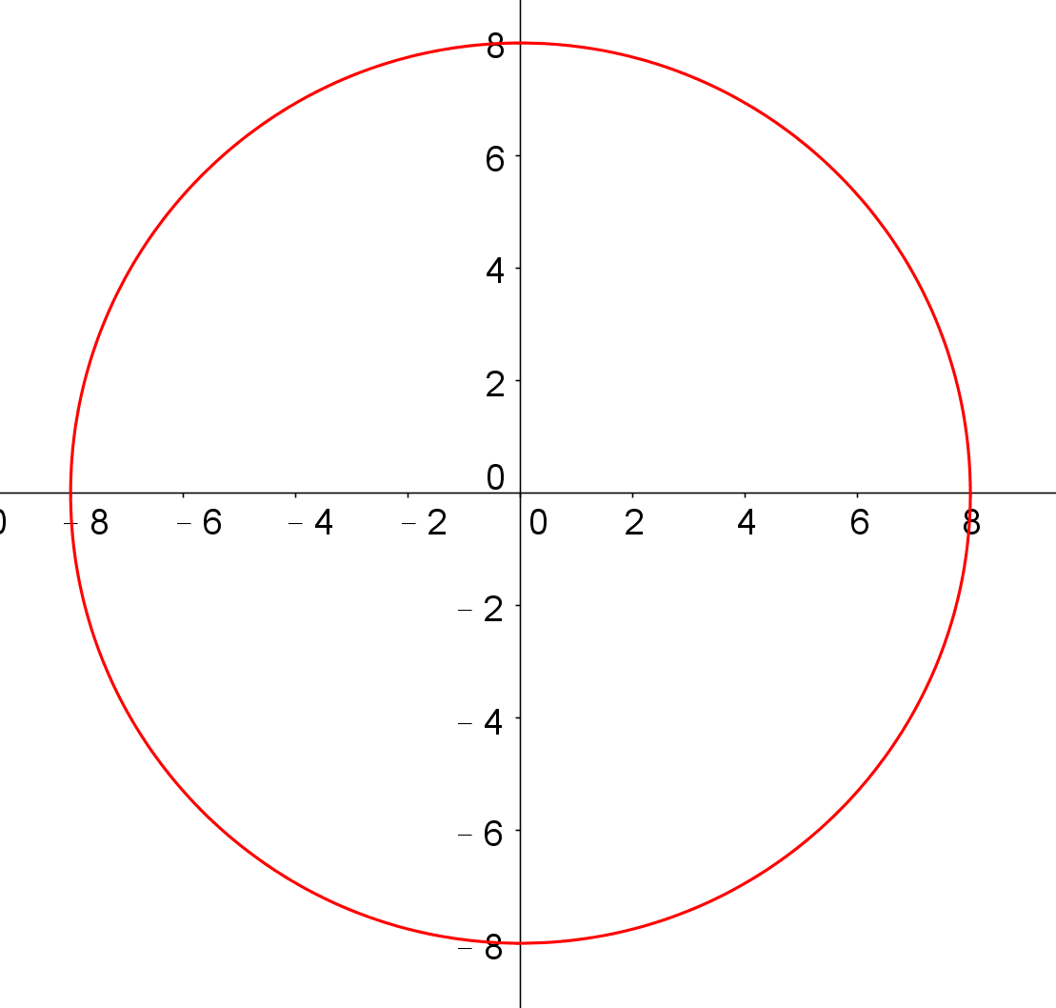 When $x=0$, $z^{2}=64-y^{2}$
$y^{2}+z^{2}=8^{2}$, which is a circle of radius 8.

The graph of $4x^{2}+y^{2}+z^{2}=64$ is composed of two parts:
$z=+\sqrt{64-4x^{2}-y^{2}}$ and $z=-\sqrt{64-4x^{2}-y^{2}}$
The given graph is a top half of ellipsoid, shown below:

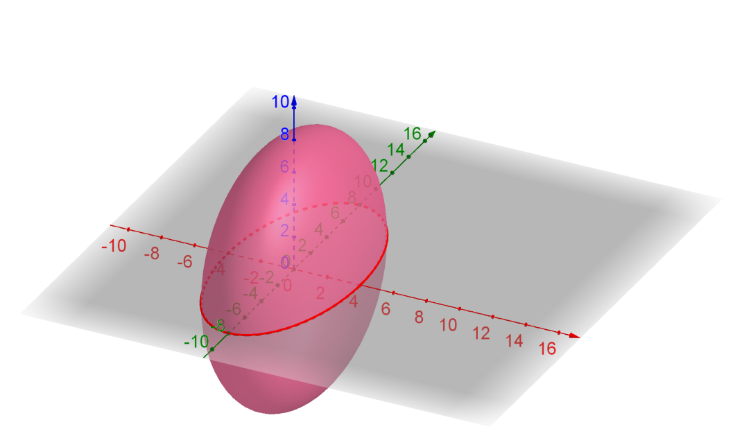
$$z=-\sqrt{64-4x^{2}-y^{2}}$$

$$z=+\sqrt{64-4x^{2}-y^{2}}$$

3. Sketch the graph $-\frac{x^{2}}{4}-\frac{y^{2}}{9}+\frac{z^{2}}{16}=1$
(A) x-y plane view
When z = 0, $-\frac{x^{2}}{4}-\frac{y^{2}}{9}=1$, which is an empty set for $\left(x,y\right)$.
When z = $±4$, $-\frac{x^{2}}{4}-\frac{y^{2}}{9}=0$ , we get two points $\left(0,0,4\right), \left(0,0,-4\right)$
When $z>4 or z<-4$, take $z=k$, $\frac{x^{2}}{4}+\frac{y^{2}}{9}=\frac{k^{2}}{16}-1, \frac{x^{2}}{\frac{4}{\frac{k^{2}}{16}-1}}+\frac{y^{2}}{\frac{9}{\frac{k^{2}}{16}-1}}=1$, which is an ellipse.
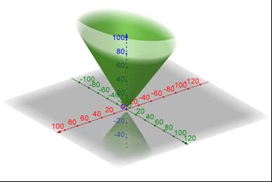
(B) x-z plane view
When $y=0 (or any constant k)$,
$-\frac{x^{2}}{4}+\frac{z^{2}}{16}=1, \frac{z^{2}}{16}-\frac{x^{2}}{4}=1$,
which is a hyperbola.

(C) y-z plane view
When $x=0 (or any constant k)$,
$-\frac{y^{2}}{9}+\frac{z^{2}}{16}=1, \frac{z^{2}}{16}-\frac{y^{2}}{9}=1,$
which is a hyperbola.

The graph, which is a two sheeted- hyperboloid, is shown on the left.

